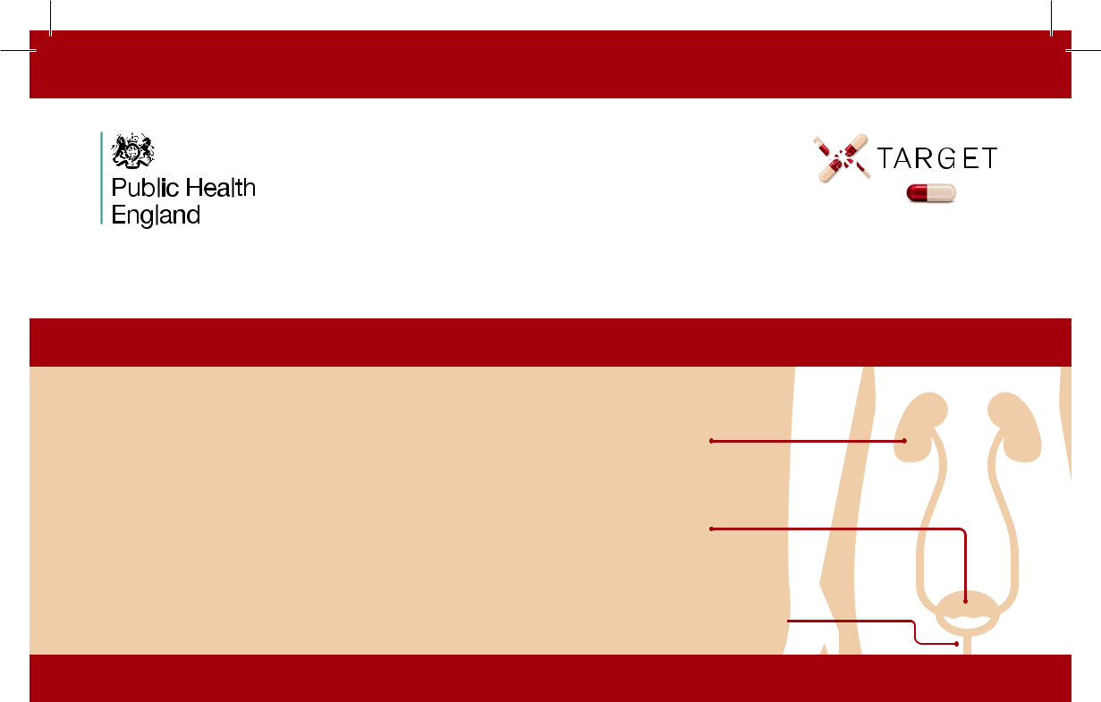

URINARY TRACT


INFECTIONS (UTIs)

A leaflet for adults with suspected UTI

What is a UTI?

A urinary tract infection (UTI) occurs when bacteria in any part of the urine system cause symptoms.

Diagnosis is made mainly on your symptoms. Urine dipsticks are only used in women under 65 without catheters.

Kidneys
make urine

Bladder
stores urine

Urethra takes
urine out of the body

What can you do to help prevent a UTI?

Are you drinking enough? Look at the colour of your urine.

Drink more

Drink enough fluid (6 -8 glasses) so that you pass urine regularly during the day, and to avoid feeling thirsty, especially during hot weather.

Your bladder can be irritated by too much alcohol, fizzy drinks or caffeine.

Prevent constipation; ask for advice if needed.

If diabetic, maintain good control of blood sugar levels.

Stop bacteria spreading from your bowel into your bladder:

- Keep the genital area clean and dry; avoid scented soaps

- Change incontinence pads often, and clean genital area if soiled

- Pass urine after having sex

- Women should wash the external vaginal area with water before and after sex, and wipe genitals from front to back after using the toilet

If you have recurrent UTIs

D-mannose or cranberry dietary supplements may help younger women

Speak to your pharmacist or GP for advice on how to prevent UTIs

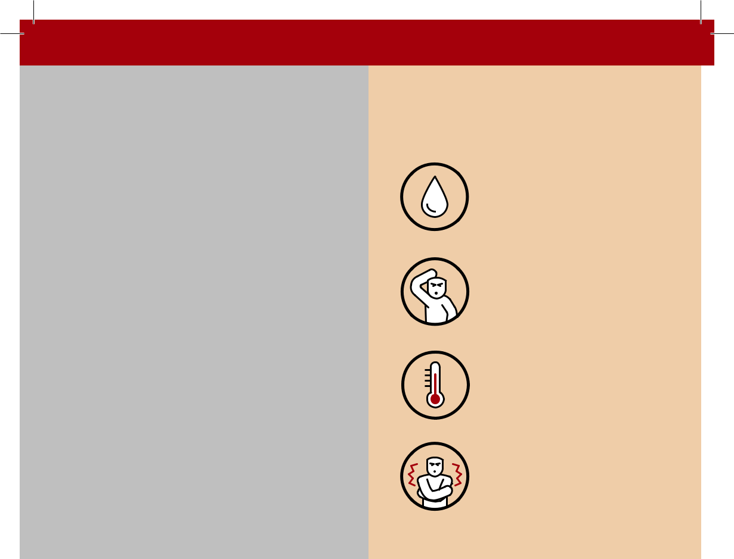
What symptoms should you look out for?

Signs/symptoms in ALL adults:

- Burning pain when passing urine

- A new need to pass urine in the night

- Urine is a visible cloudy colour

- Passing urine more often than usual

- Feeling the need to pass urine immediately

- Blood in your urine

- Pain in your lower tummy

If you have a catheter, consider these symptoms:

- Shivering or shaking

- High or low temperature

- Kidney pain in your back just under the ribs


Symptoms of a UTI in OLDER, FRAIL adults:​

- Wetting yourself more often than usual

- New or increased
confusion, change in behaviour, or unsteadiness on feet

· High or low
temperature

· Shivering
or shaking

Urinary symptoms may also be caused by:​

- Pain or discomfort after sexual activity

- A sexually transmitted infection (STI)

- Vaginal changes during or after the menopause​

Other things that may cause confusion in older adults:

· Pain · Poor sleep

- Constipation · Side effects of
· Poor diet | medicine
· Poor diet | · Other infection
· Low mood | · Other infection
· Low mood | · Change in
· Not drinking | · Change in
· Not drinking | routine or home
enough | routine or home
enough | environment

Consider Covid-19 symptoms:

If you think you may have COVID-19 then please visit http://www.gov.uk/coronavirus or http://www.nhs.uk for the latest guidance and information

Speak to NHS111, a pharmacist or your GP if you are worried about COVID

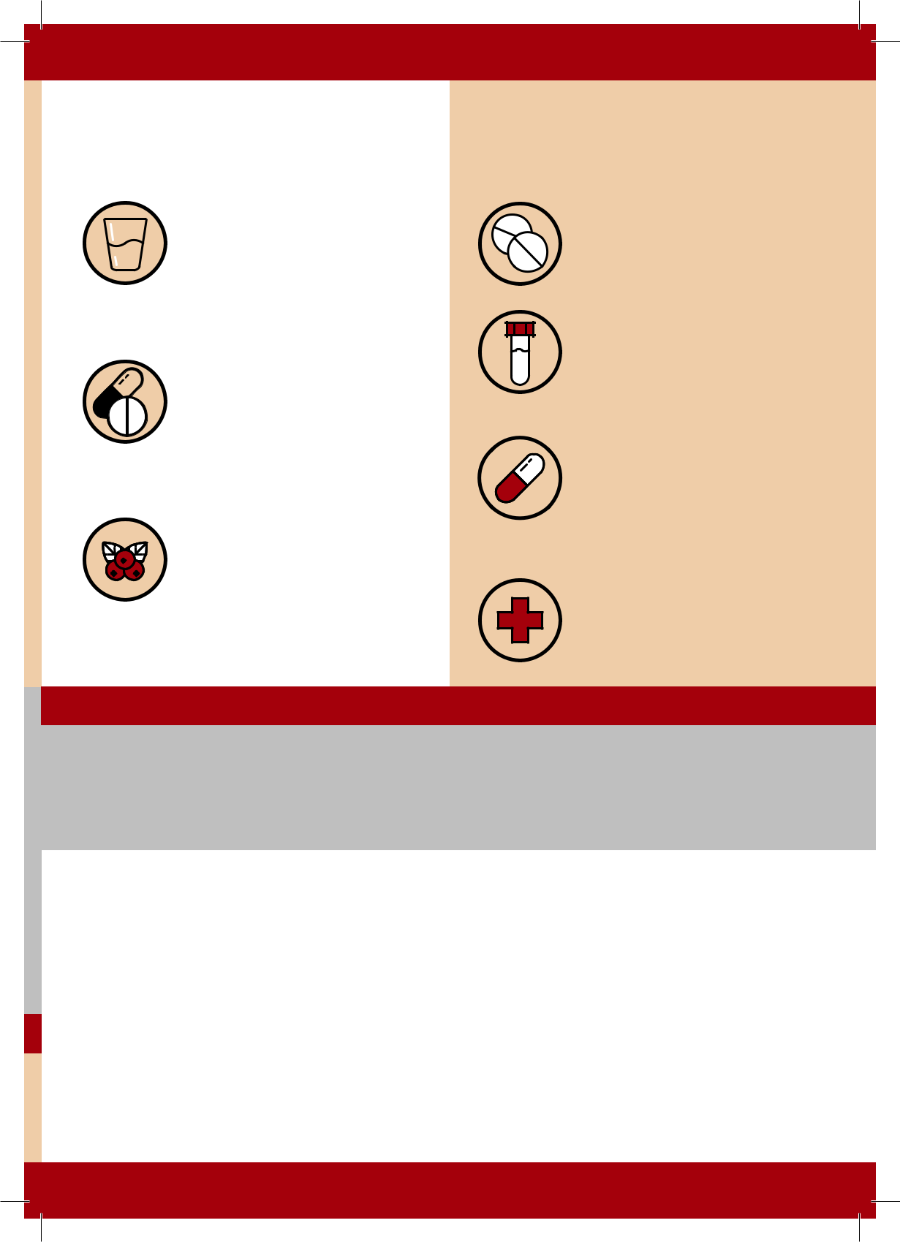
What can be done to make you feel better?

What can you do? | What might your pharmacist/
 | nurse/doctor do?​

- Drink enough fluids so that you pass pale urine regularly during the day, especially during hot weather

- Take paracetamol regularly, up to

4 times daily to relieve pain

- There is currently no evidence to support taking cranberry products or cystitis sachets to treat UTIs.

- Give self-care advice and advise pain relief (paracetamol or Ibuprofen)

- Ask you for a urine sample to test

- You may be given an antibiotic immediately, or to use if your symptoms don’t improve or you start to feel worse

- You may be referred to another healthcare provider

If you have recurrent UTIs and self-care options do not help:

- Antibiotics at night or after sex may be prescribed

- Vaginal hormone treatments may help some post menopausal women

Advice about antibiotics

- Antibiotics can be life saving for serious urine infections, but antibiotics are not always needed for mild urinary symptoms

- Antibiotics make your bodies bacteria resistant, which may make your next UTI more difficult to treat.

- Common side effects of taking antibiotics include thrush, rashes, vomiting and diarrhoea; ask for advice if you are worried

- Keep antibiotics working, only take them when your healthcare professional advises them

Taking antibiotics when you don’t need them ​puts you and your family at risk


When should you seek more urgent help?

You should consult a health professional if you have UTI symptoms and:

- Your symptoms are getting a lot worse, or not starting to improve within 2 days of starting antibiotics

- You are pregnant, male or post operation

The following symptoms are possible signs of a serious urinary infection and should be assessed urgently:



Shivering, chills
and muscle pain
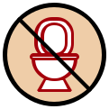

Not passing
urine all day


Trouble
breathing


Visible blood
in your urine

Feeling very
confused, drowsy

or slurred speech


Temperature is
above 38ºC
or less than 36ºC


Kidney pain in
your back just
under the ribs


Very
cold skin

Contact your GP Practice or

NHS 111 (England and Wales) Dial 111 (Scotland) GP practice (NI)
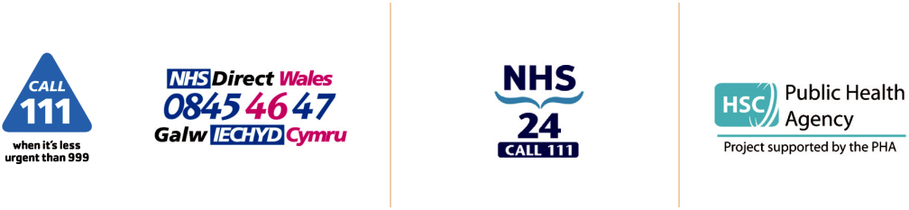

www.111.nhs.uk www.111.wales.nhs.uk www.nhs24.scot


Trust your instincts, ask for advice if you are
not sure how urgent your symptoms are

TARGET is operated by the UK Health Security Agency. Developed in collaboration with professional medical bodies, Version 1.1, March 2021, Revision: March 2023

